School of Future Tech

Case Study Report

on

MCL Studio

Markdown Component Layout Studio

by

Aaryan Kuchekar

B.Tech CSE • ITM Skills University

GitHub: Aaryan0612

Index
Abstract
Project Explained Simply
Problem Statement
Objectives
Technology Stack
React Concepts Demonstrated
System Architecture
Component Architecture
Features Implemented
Requirement Mapping
Implementation Details
Screenshots
Competitive Analysis
Major Engineering Decisions
Challenges Faced During Development
Results and Observations
Future Scope
Conclusion
GitHub Repository Link
Live Deployment Link
References

1. Abstract
MCL Studio is a frontend-only React and Vite application that transforms a constrained markdown-like language into a validated layout canvas. User input is tokenized, converted into an Abstract Syntax Tree (AST), structurally validated, and then rendered as a synchronized layout preview. The project combines product usability with engineering depth through AST inspection, graph visualization, persistence, export support, and diagnostics.

2. Project Explained Simply
Traditional markdown is useful for headings and paragraphs, but it is not naturally suited for structured layout. MCL Studio introduces a small layout language where the user writes source text in the editor and the application understands that structure before rendering it. Instead of guessing how to display raw text, the app tokenizes the input, builds an AST, validates it, and then renders a layout canvas.
1. The user writes layout markdown.
2. The tokenizer converts source text into tokens.
3. The AST builder creates a tree structure from the tokens.
4. The validator checks grammar and width rules.
5. The renderer turns the validated AST into visible layout output.

3. Problem Statement
The case study problem was to build a React application that can interpret a markdown-like layout language, transform it into a structured intermediate representation, validate that representation, and render it as a live layout preview. The project also needed enough internal visibility to demonstrate the parser pipeline clearly during evaluation.

4. Objectives
1. Build a structured markdown-like layout language.
2. Parse user input into tokens with line and column metadata.
3. Generate an AST from the token stream.
4. Validate structural nesting and width constraints.
5. Render a live layout preview from the AST.
6. Expose AST structure through inspection and graph views.
7. Support persistence and AST export.

5. Technology Stack
Area | Technology | Reason
Frontend | React 19 | Component-driven UI and state orchestration
Build Tool | Vite 8 | Fast development and clean static build output
Language | JavaScript | Lightweight implementation aligned to scope
Testing | Automated validation stack | Supports reliability and regression checking
Deployment | Vercel | Static deployment for a Vite frontend
Persistence | Browser localStorage | Restore workspace content across reloads

6. React Concepts Demonstrated
Concept | Usage in Project
Components | EditorPanel, PreviewPanel, ASTInspector, AppHeader, DiagnosticsBar
Props | Parent-child communication from AppShell into editor, preview, and AST tools
useState | rawText, selectedNodeId, activeTemplateId, exportState, layout boundary mode
useEffect | persistence updates, debounce timing, and editor source-focus synchronization
Custom Hooks | useParser, useLocalStorage, useDebouncedValue
Controlled Components | The main editor textarea is controlled by React state
Conditional Rendering | Preview empty state, graph/outline mode, diagnostics state changes
Local Storage | Workspace persistence using browser storage

This section is especially valuable for viva because it ties React terminology directly to actual project files instead of using generic examples.

7. System Architecture
MCL Studio is built as a parser-driven frontend application. Rendering does not happen directly from raw text. Instead, user input flows through a parsing pipeline and only then becomes UI.
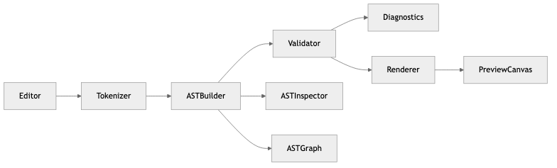
Figure 1. High-level architecture of the MCL Studio parser pipeline.

• The editor owns raw layout input.
• The tokenizer converts text into structured tokens.
• The AST builder converts tokens into a tree.
• The validator checks structure and width correctness.
• The renderer turns the AST into visible React UI.
• The inspector and graph visualize the AST rather than raw text.

8. Component Architecture
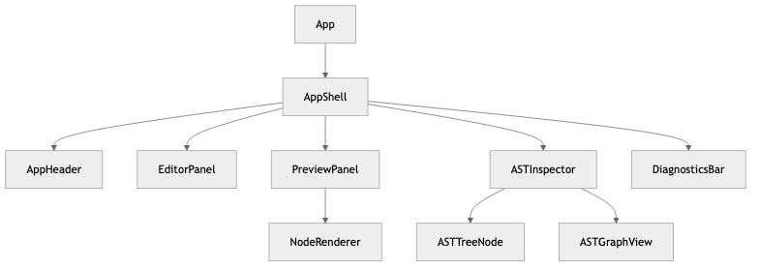
Figure 2. React component hierarchy centered around AppShell.

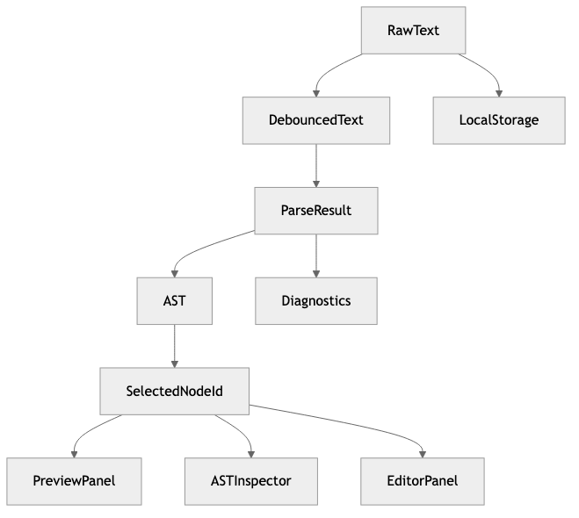
Figure 3. Centralized state flow from raw editor input to synchronized UI panels.

• AppShell manages shared state such as raw text, selection state, template choice, and parser output.
• EditorPanel handles input, cursor-linked source focus, and template loading.
• PreviewPanel renders the layout canvas.
• NodeRenderer recursively renders AST nodes into React elements.
• ASTInspector displays outline mode, graph mode, validation issues, and diagnostics.
• DiagnosticsBar provides a compact status footer.

9. Features Implemented
• Structured layout editor
• Tokenizer with source metadata
• AST builder with node IDs and source ranges
• Structural validator
• Diagnostics summary
• Live layout canvas
• AST outline inspector
• AST graph view
• Template loader
• AST export
• Browser persistence

10. Requirement Mapping
Requirement | Implementation
Markdown Editor | src/components/editor/EditorPanel.jsx
Live Preview | src/components/preview/PreviewPanel.jsx and NodeRenderer.jsx
AST Generation | src/parser/astBuilder.js
Validation | src/parser/validator.js
Diagnostics | src/utils/diagnostics.js and astDepth.js
Persistence | src/hooks/useLocalStorage.js
Export | handleExportAst() inside src/components/layout/AppShell.jsx
AST Visualization | src/components/ast/ASTInspector.jsx and ASTGraphView.jsx

11. Implementation Details
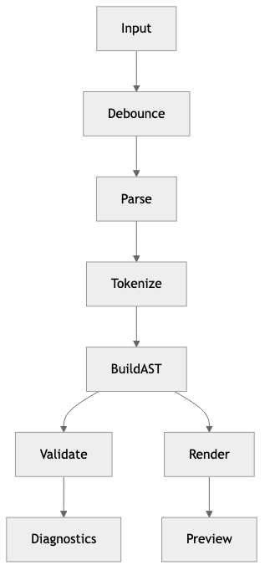
Figure 4. Parsing pipeline from input to rendered preview.

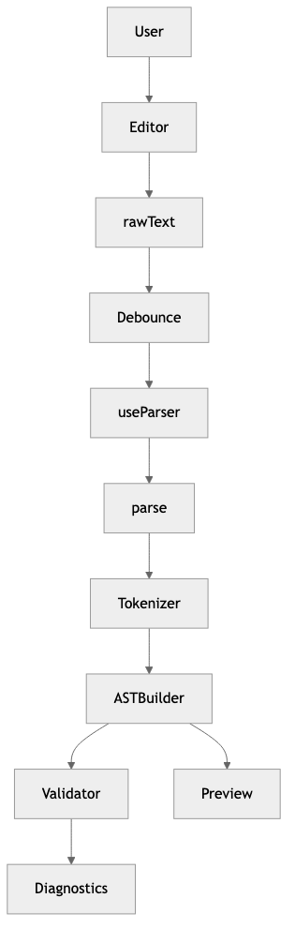
Figure 5. Runtime data flow from user input to parser output and preview rendering.

Frozen Grammar
• ROOT can contain ROW, INFO, headings, and text.
• ROW can contain COL only.
• COL can contain H1, H2, H3, TEXT, and INFO only.
• Nested row inside col is invalid in version 1.
Grammar Specification
ROOT -> ROW | INFO | H1 | H2 | H3 | TEXT
ROW -> COL
COL -> H1 | H2 | H3 | TEXT | INFO
INFO -> H1 | H2 | H3 | TEXT
:::row
:::col width=100
# Welcome
Describe your layout.
:::
:::
AST Example
root
└─ row
└─ col
├─ H1
└─ text
The AST stores node type, children, source line range, and width or content metadata where appropriate. This is what makes validation, graph visualization, and renderer consistency possible.
Complexity Analysis
Operation | Complexity
Tokenization | O(n)
AST Building | O(n)
Validation | O(n)
Rendering | O(n)

12. Screenshots
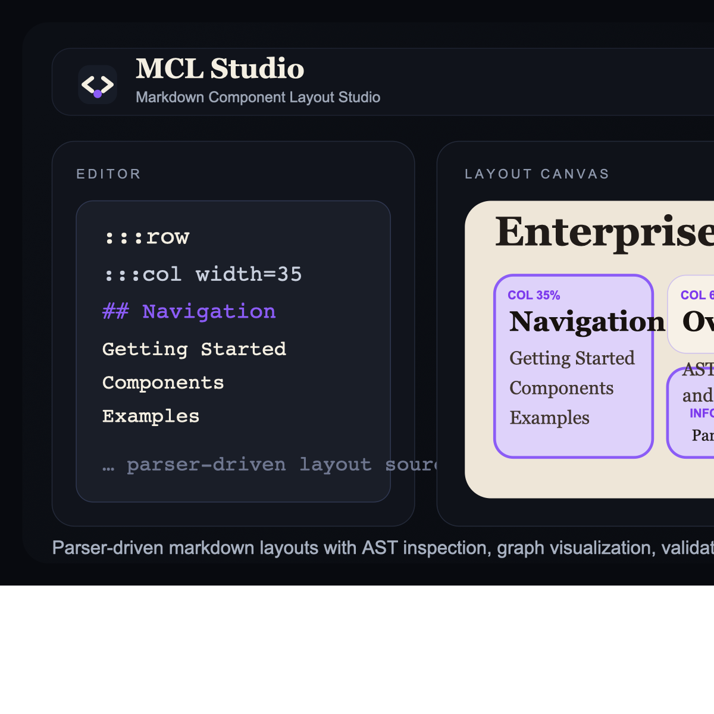
Figure 6. Main workspace showing the branded editor-to-canvas workflow.

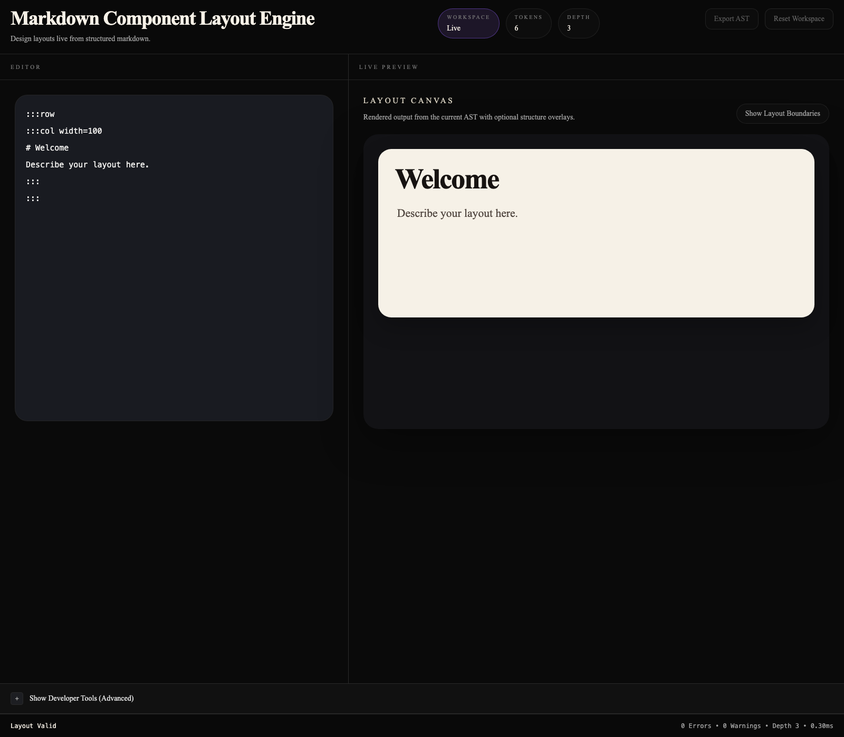
Figure 7. Controlled editor panel used for structured layout authoring.

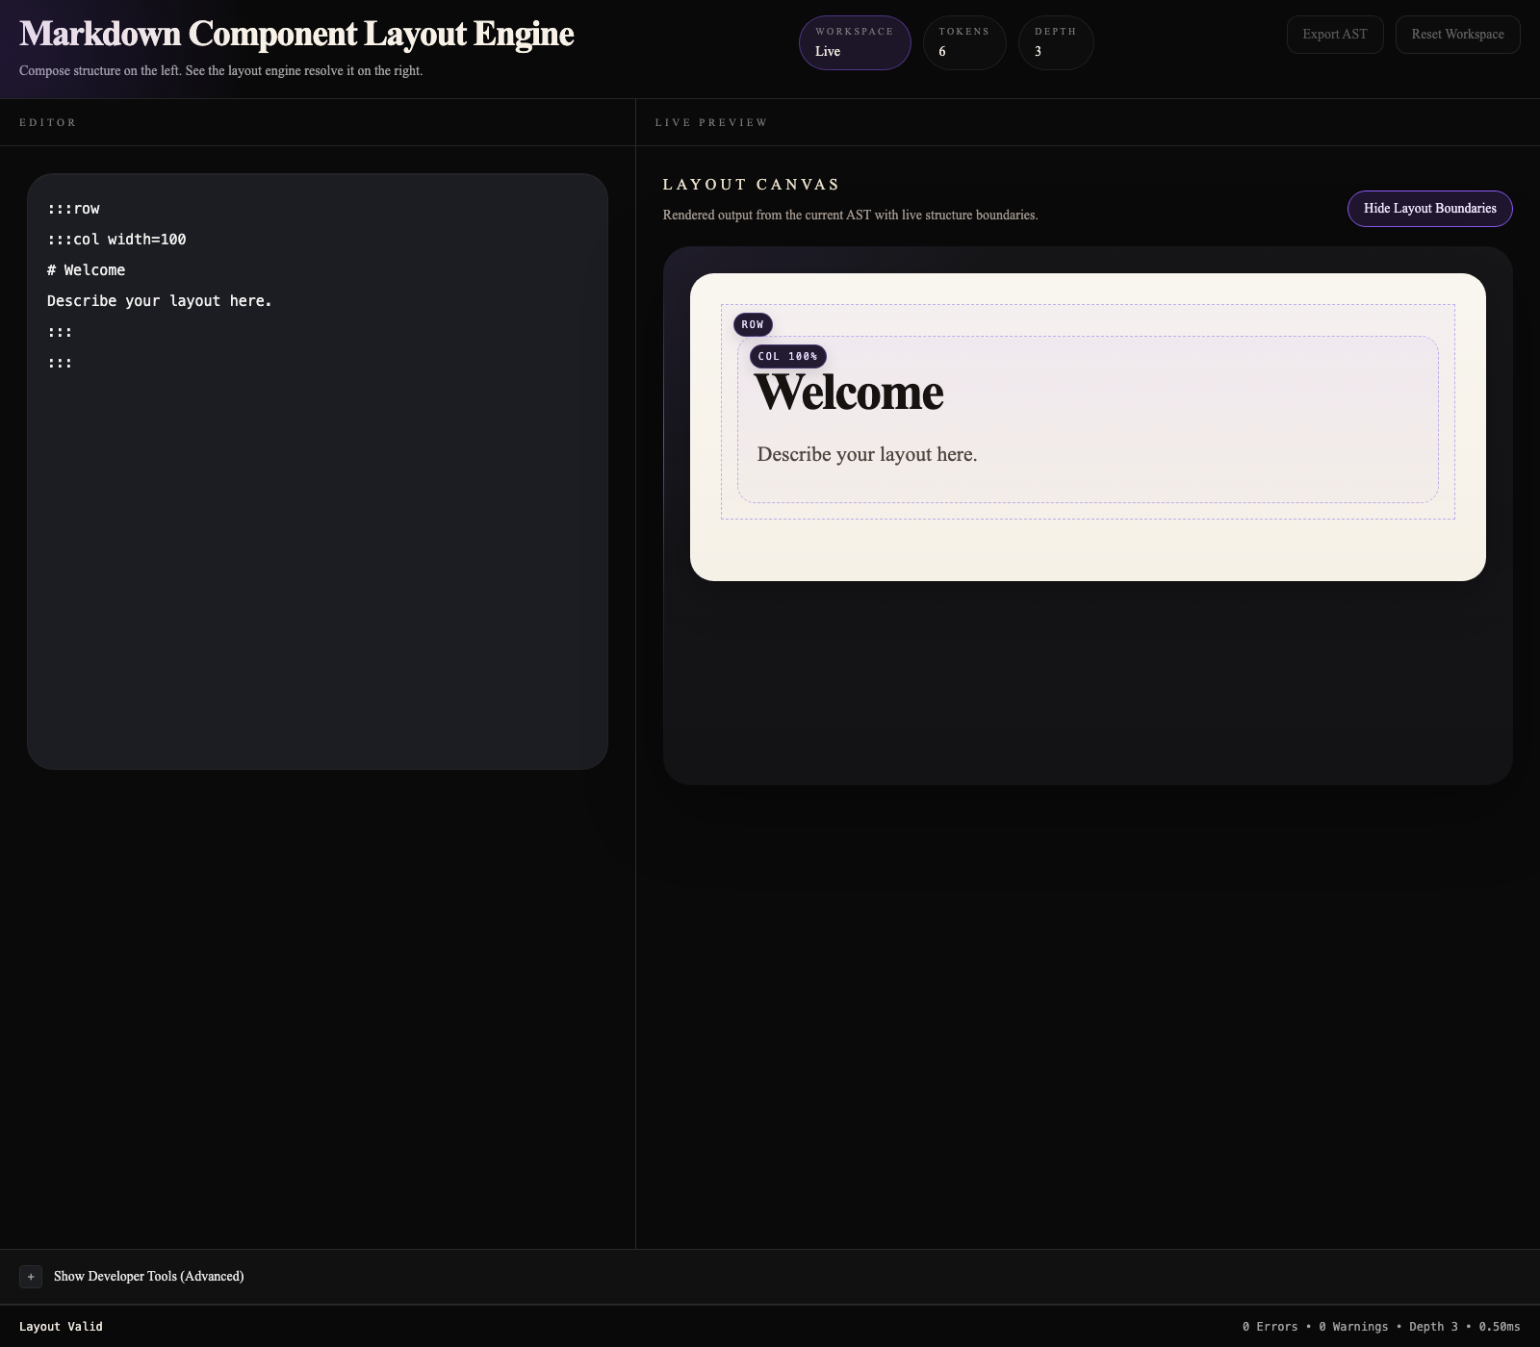
Figure 8. Layout canvas rendering the AST as visible structured output.

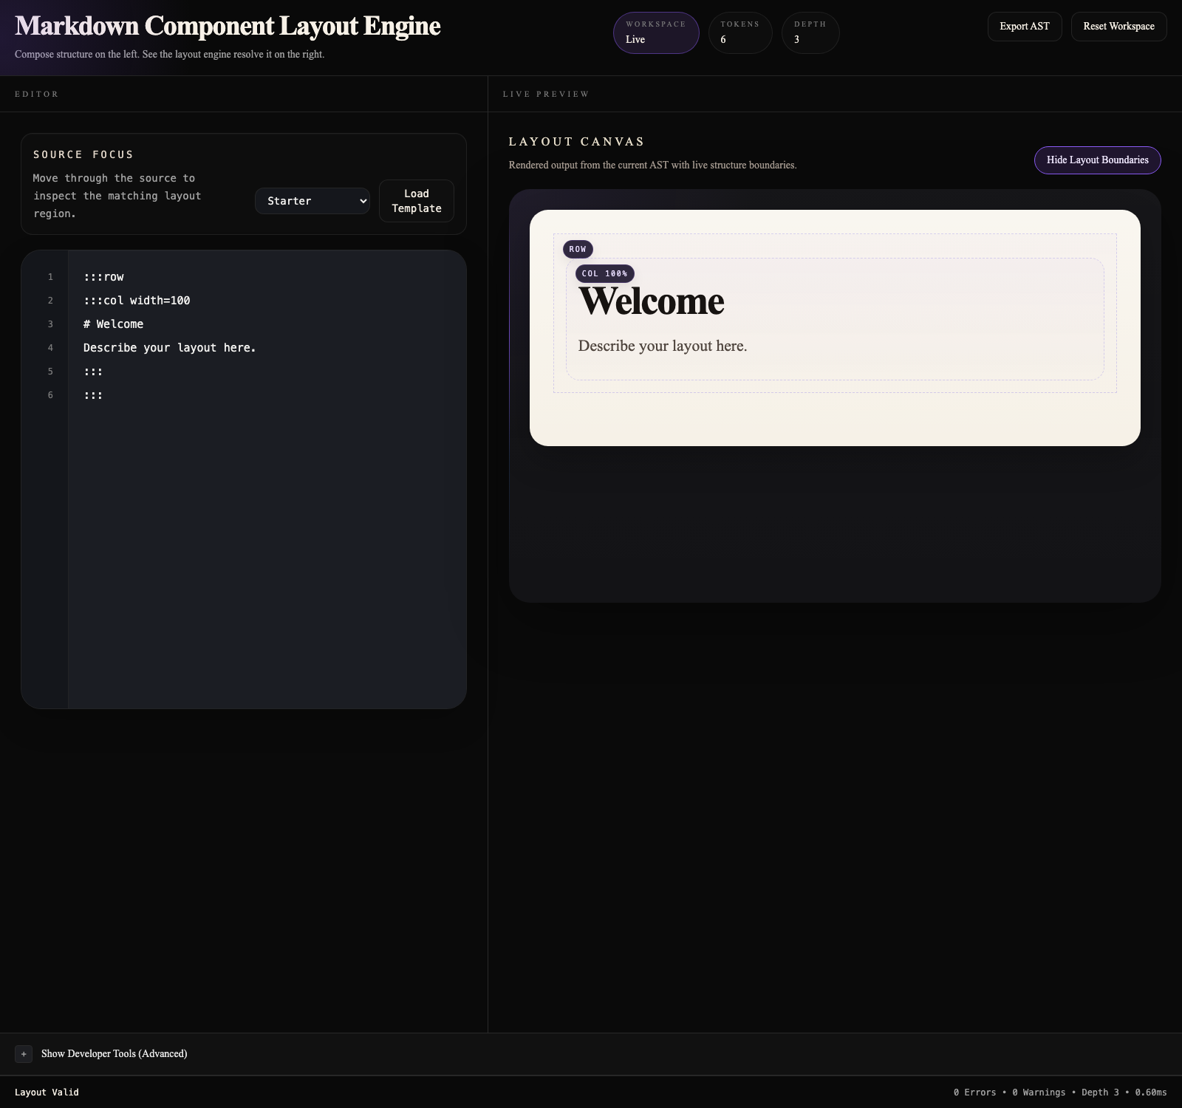
Figure 9. AST graph visualization for parser inspection.

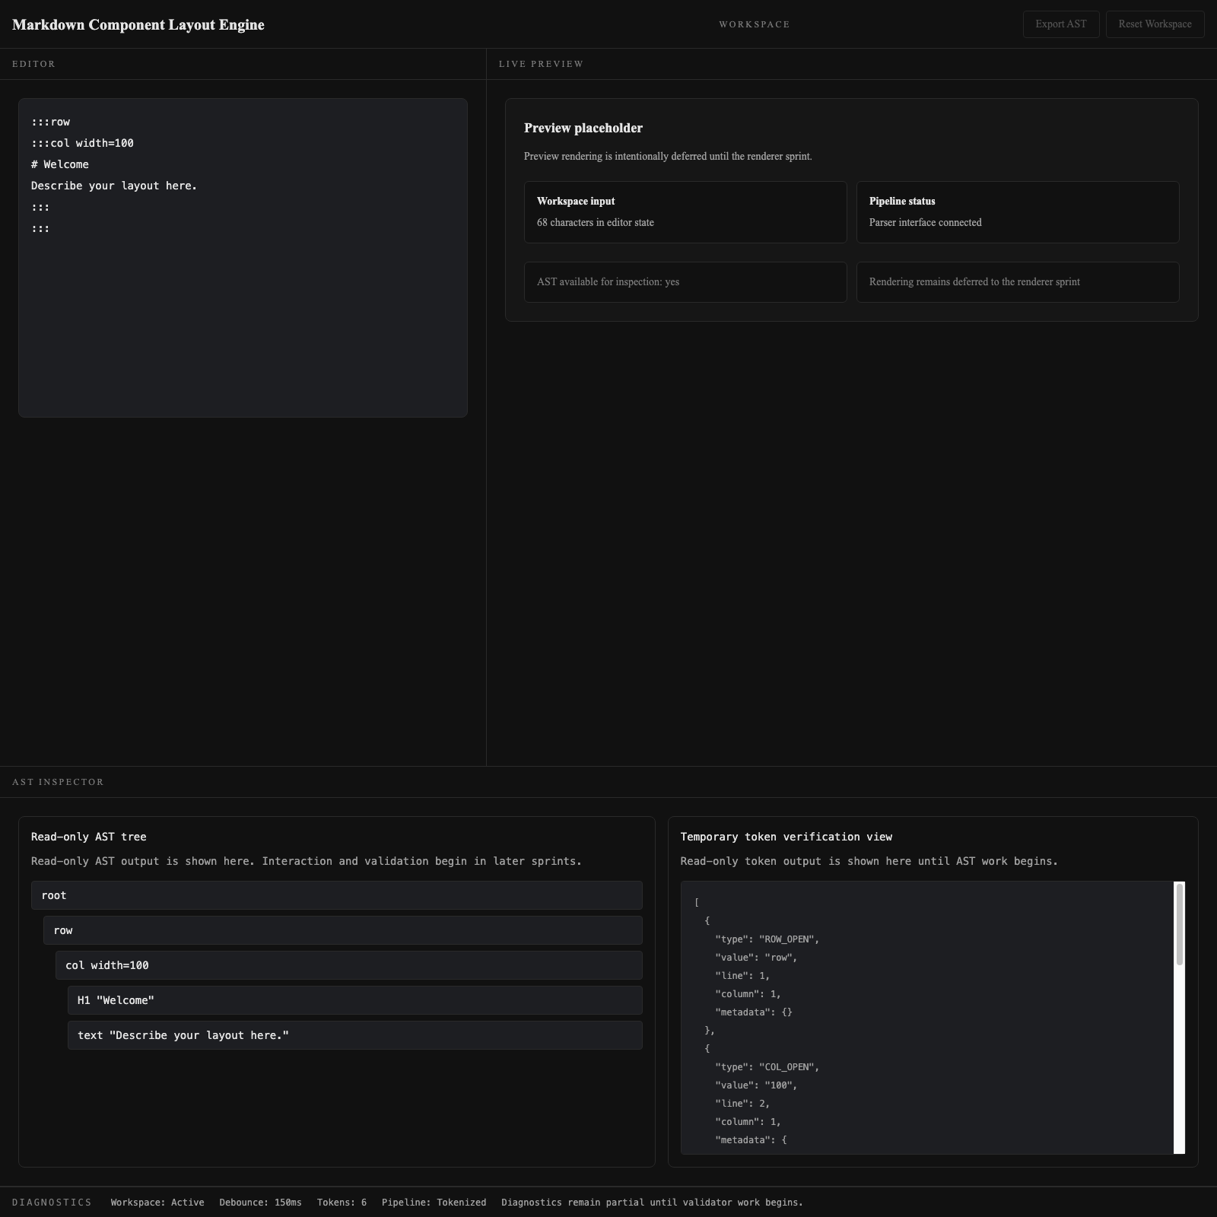
Figure 10. AST outline inspector showing hierarchical node traversal.

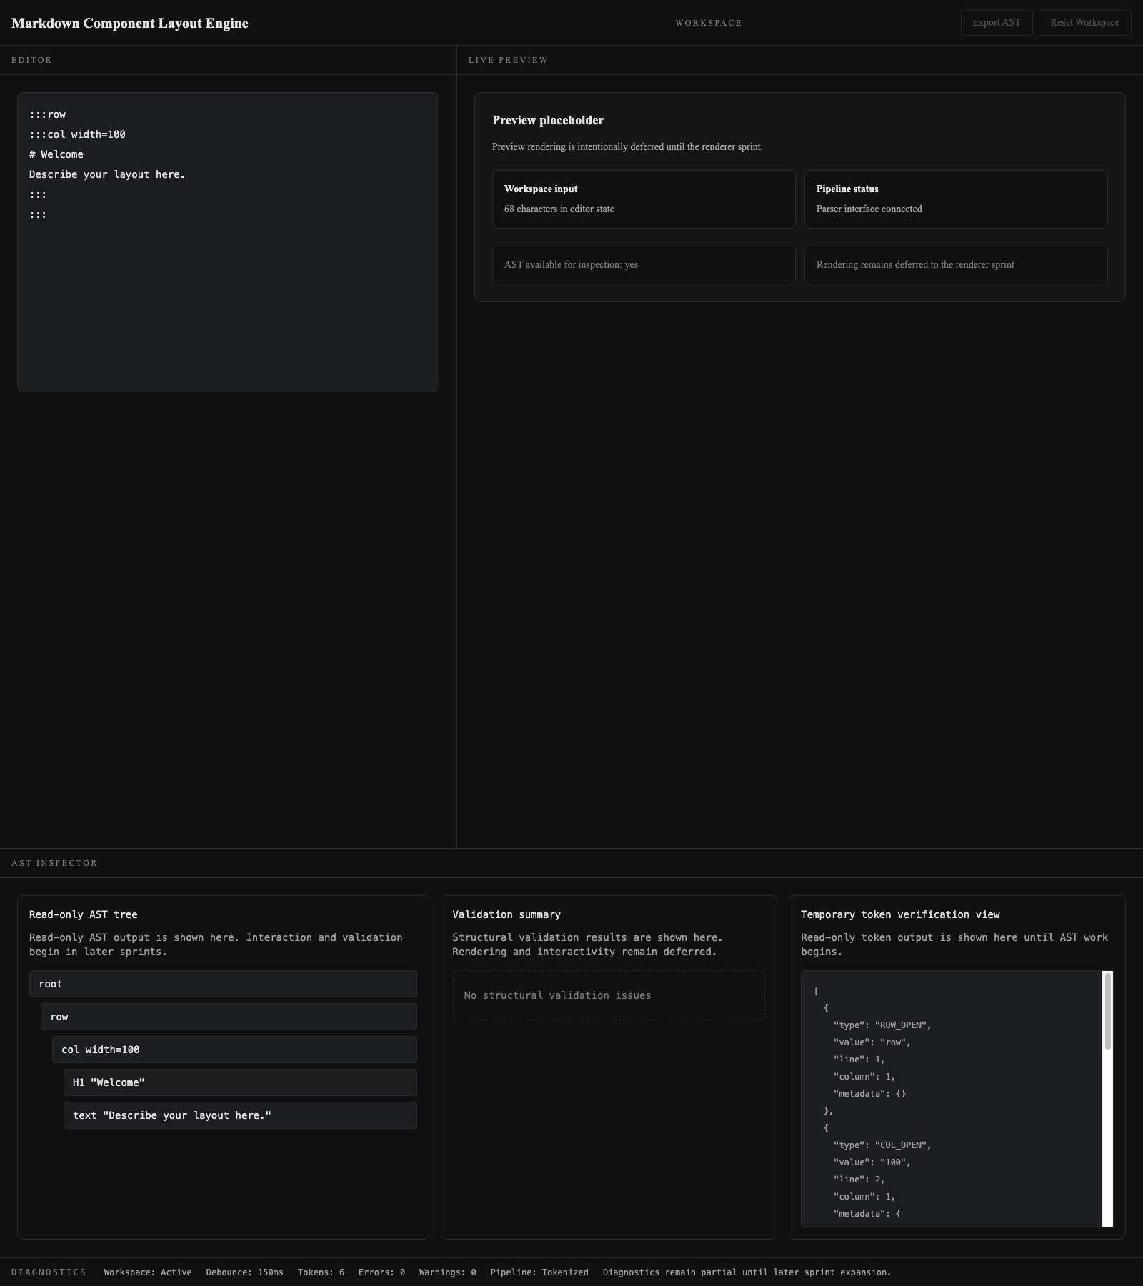
Figure 11. Diagnostics and validation panel for engineering visibility.


Figure 12. Validation errors demonstrating grammar enforcement.

The reviewed Google Docs copy may also include additional captures for template loading, export success, and persistence restore states, depending on the final submission version.

13. Competitive Analysis
Tool | Layout Grammar | AST View | Diagnostics | Export AST
Traditional Markdown Previewers | No | No | No | No
Obsidian | Partial | No | No | No
Notion | Different model | No | No | No
MCL Studio | Yes | Yes | Yes | Yes

14. Major Engineering Decisions
Why React
React was chosen because the application depends on multiple synchronized panels and shared state.
Why Vite
Vite was chosen for fast development and simple static deployment.
Why AST
An AST made validation, graph visualization, export, and rendering consistency possible.
Why LocalStorage
Browser persistence was sufficient for the scope without requiring backend infrastructure.
Why Custom Grammar
Standard markdown cannot express the required layout structure clearly enough.
Why Frontend-only
The core value of the project is client-side parsing, validation, and rendering.

15. Challenges Faced During Development
Problem: Parser validation issues
Cause → Solution → Learning: A dedicated structural validator was built so invalid nesting could be detected clearly and consistently.
Problem: AST synchronization issues
Cause → Solution → Learning: Selection safety and node existence checks were centralized in AppShell to keep editor, inspector, and preview aligned.
Problem: Selection mapping problems
Cause → Solution → Learning: Node-type-aware highlighting was introduced so containers and leaf nodes respond differently and more clearly.
Problem: Layout fidelity problems
Cause → Solution → Learning: The preview was refined so rows and columns communicate structure instead of only rendering text content.
Problem: Export and persistence
Cause → Solution → Learning: Browser APIs were wrapped safely so user workflows remain usable even when export or storage failures occur.

16. Results and Observations
MCL Studio successfully achieved its core goals. It parses structured layout input, builds a source-aware AST, validates structure, renders a live layout canvas, visualizes the AST in two forms, supports persistence, and exports ast.json. The final architecture also demonstrates strong separation of concerns because parser logic is not embedded in UI components and rendering is AST-driven.

17. Future Scope
• Nested layouts through a grammar v2
• Additional block types beyond row, col, and info
• Theme-aware preview rendering
• Reusable template import and export workflows
• Collaborative editing with backend persistence

18. Conclusion
MCL Studio demonstrates how a React application can combine component architecture with parser-driven design. It goes beyond standard markdown rendering by treating layout input as a small formal language. Through tokenization, AST construction, structural validation, diagnostics, and live rendering, the project serves as both a usable product and a technically strong academic case study.

19. GitHub Repository Link
https://github.com/Aaryan0612/MCL-Studio

20. Live Deployment Link
https://mcl-studio.vercel.app

21. References
• React Official Documentation
• Vite Official Documentation
• Browser APIs for localStorage, Blob, and download links
• MCL Studio repository source files and release documentation

